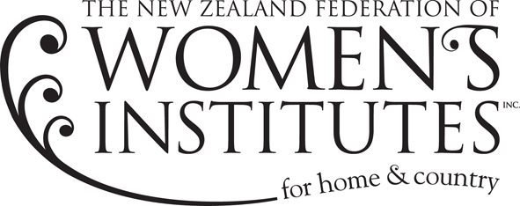

MEDICAL RESEARCH SCHOLARSHIPS

1971 | Trace elements in soil as they affect human nutrition
1972 | McKenzie & Robins-Research into Infective Hepatitis
1973 | Dr Nicholson-Energy balance and obesity in New Zealand Women
1974 | Heather Ward-Investigating causes of deafness in children
1975 | Blanshard & Maclean-Trace elements, zinc and copper in human metabolism
1976 | Anne Guthrie - Masters Degree in Home Science
1977 | Margaret Braae - Salt intake in humans
1978 | Ruth Dunlop - Research into the trace element selenium
1980 | Hodges & Yates – Child Health
1981 | Shirley Holdaway – Developing sequencing equipment for very disabled children
1982 | Mrs George James – Pacific Paramedical Centre
1983 | Nic Foster – Research into Cot Deaths
1984 | Alison Wesley – Research into Cystic Fibrosis
1985 | Child Cancer Foundation
1986 | Asthma Foundation
1987 | Assoc Prof. R M Faulls – Purchase of specialised equipment for research into Alzheimer’s Disease
1988 | Dr Russell Lenert – Research into Blindness in Diabetics
1990 | National Kidney Foundation
1992 | Motor Neurone Society of New Zealand
1994 | Peter Luxford Foundation
1996 | National Institute Water and Air (N.I.W.A.)
1998 | NZ Spinal Trust
2000 | Endometriosis
2002 | Bone and Joint Trust
2004 | Spinal Cord Society New Zealand (Inc)
2006 | Spinal Cord Society New Zealand (Inc)
2008 | The Neurological Foundation of New Zealand- University of Canterbury
2010 | Kidney Kids of NZ Inc.
2012 | BLiSS Project – University of Otago
2014 | Minds for Minds Trust – Research on the Autism spectrum
2016 | Ferrier Institute, Victoria University – Alzheimers research
2018 | Dept. Ophthalmology Auckland University-nailfold capillary changes in glaucoma
2020 | Pathology & Biomedical Sciences, Otago University- Vitamin C and impact on cancer
2022 | Wellington Regional Hospital- early diagnosis of cerebral palsy
2024 | Matai Medical Research Institute – Gisborne, Concussion: making the invisible visible using amplified MRI

